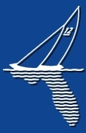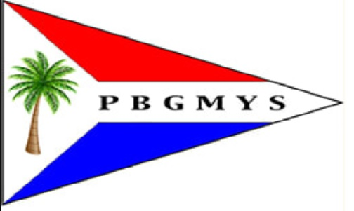

Valentine's EC-12 Regatta

Region 7 Championship

A regatta of the Florida EC-12 Association 2021-2022 Series

February 12 & 13, 2022

Hosted by

Palm Beach Gardens Model Yacht Squadron

AMYA Sanctioned Club No. 94

Rules: The regatta will be governed by the ‘rules’ as defined in the Racing rules of sailing, as modified by Appendix E.

Eligibility: The regatta is open to all skippers with boats registered with the EC-12 Class.

Schedule: Registration 8:30 AM Saturday

Skippers meetings 9:00 AM Saturday, 9:00 AM Sunday
Saturday races begin at 9:30 AM, No races will start after 4:00 PM.
Sunday races begin at 9:30 AM. No races will start after 12:30 PM.
The RD will extend the racing hours if needed due to weather delays or other unforeseen circumstances.

Location: NEW POND. Located in Hobe Sound Florida at 1425 SE Bridge Road just West of the I95 exit. Note there is no Florida Turnpike exit at Bridge Road
Detailed directions will be provided, if necessary.
A little bit about the new pond: open on all sides to the wind with very minimal blockage presenting an ideal venue for model sailboat racing.

Sailing Instructions: The standard Sailing instructions for the Florida EC-12 Association are posted at: http://www.floridaec12.com/regattas.html A copy will be available also at the regatta.
The referenced sailing instructions are modified for this regatta by striking out 3.2. This then means that the I flag will not be flying, thus permitting a boat OCS prior to the start signal to sail to the start side of the line to remedy her start without having to sail around one of the ends of the starting line.

Entry: Eligible boats may be entered by completing an Online Entry with an entry fee of $35.00, guests $8. Entry fee includes coffee, doughnuts, and drinks on Saturday and Sunday, plus lunch on Saturday

Scoring: The regatta will be scored under the AMYA Heat Management System (P&R/EORS) using the Low Point Scoring method of RRS Appendix A. To start the regatta, skippers will be placed in either the A- or B-fleet based on the National Seeding List. No seeding heats. A boat's worst score will be excluded. A Second worst score will be excluded if 12 or more races are sailed.

Trophies: Trophies of unparalleled taste and distinction will be awarded based on the number of entries received by the entry deadline. 3 trophies for 19 entries or less; 4 trophies for 20 – 26 entries; 5 trophies for 27 or more entries.

Please Enter Online by going to:

http://www.floridaec12.com/regattas.html

or

https://www.theamya.org/regatta/nextYear/race_date.php

and Click the "Online Entry" Button

If you are unable to do online entry, send an e-mail to Jon Luscomb pickupstyxj24@gmail.com

The entry time for this regatta is open to the day of the regatta, BUT we sure like to plan and encourage a timely entry.

Dinner will be will be discussed at the Saturday Skippers Meeting

COVID-19 SAFETY PROTOCOLS

Due to the COVID-19 Pandemic, the Palm Beach Gardens Model Yacht Squadron has committed to run a safe regatta implementing the following protocols:

- If anyone has a fever or are not feeling well, they will not be permitted at event.
- All participants are required to maintain a safe distance of at least 6 feet from one another during activities.
- Face masks may be worn by skippers and race management.
- Hand washing will be encouraged. Hand sanitizer will be available on site.
- Chairs, boat equipment, bags, will be placed at least 6 feet apart in the grass east of the walking path. Distances will be measured.
- Participants will requested not to share tools.
- Any participant or household member of a participant, who has been exposed to a person with COVID-19 within 14 days of activities or has traveled to/from any foreign country/domestic area identified by CDC or local health officials as a hot spot within the past 14 days, should not attend the regatta or any related any activities.

If you do not intend to abide by the above protocols, please do not enter. We will see you next time

Hotel Information and Directions

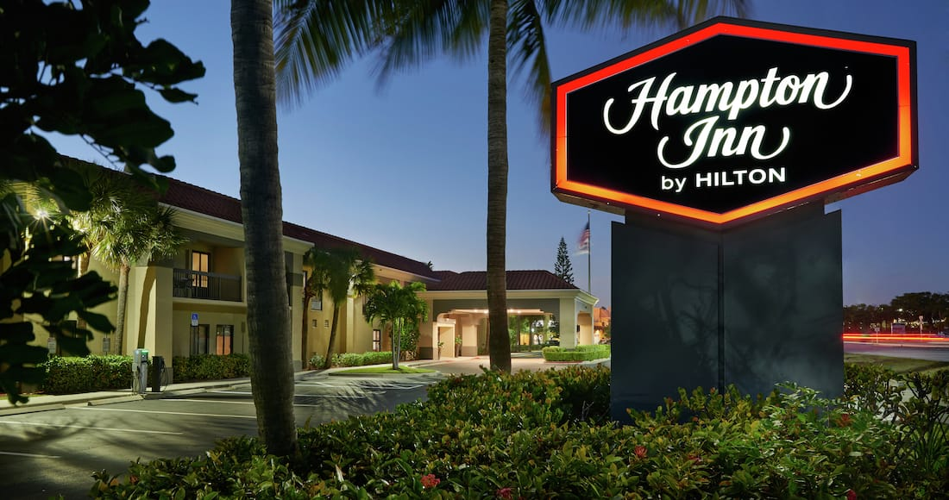

13801 U.S. Highway 1 Juno Beach, Florida 33408

It is 20 miles south of the Regatta site, about a 30 minute drive. But it is located close to Juno Beach and the Loggerhead Marine Life Center, both worth visiting

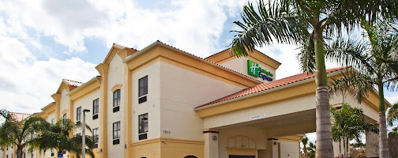

Holiday Inn Express Stuart, an IHG Hotel

7900 SW Lost River Road, Stuart, Florida 34997

Located 6 Miles North of the New Pond, a 10 minute drive

4000 RCA Boulevard, Palm Beach Gardens, FL 33410

(561) 622-8888

www.marriott.com/pbipg

Hilton Garden Inn Palm Beach Gardens

3505 Kyoto Gardens Dr Palm Beach Gardens, FL 33418 Book online or call 1-800-238-0767

Hampton Inn Palm Beach Gardens

4001 RCA Blvd.

Palm Beach Gardens, FL 33410

561-625-8880

Trip Advisor Reviews: 4.5 Stars (744 Reviews)

757 US Highway 1, North Palm Beach, Fl (561) 848-1424

Best Western Plus Palm Beach Gardens Hotel and Suites

11360 U.S. Highway 1

Palm Beach Gardens, FL 33408

561-844-8448

Trip Advisor Reviews: 4 Stars (530 Reviews)

